

Project Based Learning

On

RCC ISOLATED FOOTING DEATILING BY USING AUTOCAD
By:-

BHUKYA HARISH (25X01A0106)
CHANGALA RAMOLA SHARON (25X01A0111)
USARTHI SANDEEP KUMAR(25X01A0151)
BHUKYA NIKHIL KUMAR (26X05A0102)

UNDER THE GUIDANCE OF
MR. SHAIK KHALEEL
AUTOCAD TRAINER

Department of Civil Engineering

Narsimha Reddy Engineering College (UGC- Autonomous) Approved by AICTE,Affiliated to JNTUH, Accredited by NBA & NAAC with A-Grade) Maisammaguda (V), Kompally, Secunderabad, - 500100.(2026-2027)

ABSTRACT
An isolated footing is a structural foundation designed to support a single column and safely transfer its load to the underlying soil. It is one of the most commonly used foundation systems in low- and medium-rise buildings because of its simplicity, economy, and ease of construction. The design of an isolated footing involves determining the required footing area based on the column load and allowable soil bearing capacity. Structural checks are then carried out for bending moment, one-way shear, and punching shear to ensure adequate strength and stability. Proper reinforcement is provided in both directions to resist tensile stresses and control cracking. The depth of the footing is selected based on structural requirements and construction considerations. This study focuses on the design principles, analysis, reinforcement detailing, and construction aspects of isolated footings. A properly designed isolated footing ensures safe load transfer, limits settlement, and provides adequate stability to the supported structure while achieving economical use of materials.

INTRODUCTION

An isolated footing is a type of shallow foundation used to support a single column and transfer its load safely to the soil. It is one of the simplest and most economical foundation systems used in building construction, particularly where the soil has adequate bearing capacity and columns are spaced sufficiently apart. The footing distributes the concentrated load from the column over a larger area of soil, thereby reducing the pressure on the ground to a safe and acceptable level. Isolated footings are generally constructed in square, rectangular, or circular shapes depending on the column dimensions, loading conditions, and site requirements. The design of an isolated footing involves considering the structural loads, allowable soil bearing capacity, depth of foundation, bending moments, one-way shear, and punching shear. Reinforcement is provided to resist tensile stresses and ensure structural safety.
A properly designed isolated footing provides stability, minimizes excessive settlement, and ensures safe and efficient transfer of loads from the structure to the ground.

OBJECTIVE OF ISOLATED FOOTING

. To understand the basic concept of an isolated footing.
. To determine the required size and depth of the footing.
. To study the load transfer from the column to the soil.
. To calculate the bending moment and shear forces.
. To provide suitable reinforcement for the footing.
. To ensure the safety and stability of the foundation.
. To design an economical and durable isolated footing.

PROBLEM STATEMENT
The main problem is to design a safe and economical isolated footing for a column carrying the load of a building. The footing must transfer the column load safely to the soil without exceeding the allowable soil bearing capacity. The design should also be safe against bending, one-way shear, and punching shear. Proper dimensions, depth, and reinforcement must be selected to ensure the stability, strength, and durability of the footing.

LITERATURE REVIEW OF ISOLATED FOOTING
An isolated footing is one of the most widely used shallow foundation systems for supporting individual columns in reinforced concrete structures. Various researchers and design codes have studied its behavior with respect to soil bearing capacity, structural loads, settlement, bending, and shear.
According to IS 456:2000, the design of isolated footings should ensure adequate safety against bending, one-way shear, and punching shear. The code also provides guidelines for the minimum reinforcement, development length, and structural detailing required for reinforced concrete footings.
Punmia et al. explained that the area of an isolated footing is primarily determined from the column load and the safe bearing capacity of the soil. Proper proportioning of the footing helps maintain safe soil pressure and reduces the possibility of excessive settlement.
P. C. Varghese discussed the importance of limit-state design in reinforced concrete foundations. The design should consider both ultimate strength and serviceability requirements, including adequate reinforcement and control of cracking.
S. Ramamrutham and R. Narayanan highlighted that footing dimensions, depth, and reinforcement depend on column loads, soil conditions, and moments acting on the foundation. Proper detailing is essential for effective transfer of loads from the column to the soil.
Overall, the literature indicates that economical and safe isolated footing design requires proper assessment of soil properties, accurate load calculation, and adequate checks for bending, shear, bearing pressure, and settlement.

METHODOLOGY - ISOLATED FOOTING

S.
No.
Methodology Step Description

- Collect Design Data Collect column size, column load, soil bearing capacity, concrete
grade, steel grade, and required footing depth.
- Determine Footing Size Calculate the required footing area based on column load and safe
bearing capacity of soil.
- Select Footing Type Select a suitable isolated footing, generally square or rectangular,
based on structural and site requirements.

- Calculate Footing Thickness
- Calculate Reinforcement
- Prepare AutoCAD Setup
Determine the footing thickness considering bending, one-way shear, and punching shear requirements.
Design the required reinforcement in both directions based on bending moments and code requirements.
Set drawing units, limits, layers, text style, dimension style, and appropriate drawing scale in AutoCAD.

- Draw Plan View Draw the footing boundary, RCC column, reinforcement grid,
column centerlines, and required dimensions in plan.
- Draw Sectional View Prepare a section through the footing showing footing thickness,
column, reinforcement, PCC, and soil level.
- Detail Reinforcement Show bar diameter, spacing, bar direction, development length,
concrete cover, and reinforcement arrangement.

Add Dimensions & Annotations
Provide all necessary dimensions, levels, bar marks, notes, and construction details.

- Prepare Reinforcement Create a bar bending/reinforcement schedule showing bar mark,
Schedule diameter, spacing, quantity, and length.
- Check the Drawing Verify dimensions, reinforcement, cover, bar spacing, section
details, and consistency between plan and section.
- Final Documentation Add title block, drawing number, scale, notes, and project details,
then prepare the final drawing for printing/PDF.

TOOLS & TECHNOLOGIES
For an isolated footing detailing project using AutoCAD, the following tools and technologies are commonly used:

Tool / Technology Application
Preparation of footing plan, section, reinforcement detailing, and

AutoCAD
dimensions

Computer/Laptop Running CAD and design software
RCC Design Principles Calculation of footing size, thickness, bending and shear Structural Analysis Determination of column loads and forces acting on the footing IS 456:2000 Guidelines for reinforced concrete footing design
IS 1904 Guidelines related to foundation design
IS 1786 Specifications for reinforcement steel

Engineering

Calculations
Calculation of area, bending moment, shear and reinforcement

CAD Commands Line, Offset, Trim, Extend, Hatch, Dimension, and Text for drafting
PDF/Plotting Tools Exporting and printing the final footing drawing

EXPECTED OUTCOMES

The expected outcome of isolated footing detailing is to develop a safe, economical, and structurally reliable footing design that can effectively transfer column loads to the soil. The detailing process using AutoCAD is expected to produce accurate plan and sectional drawings showing footing dimensions, column position, reinforcement details, concrete cover, bar spacing, and other necessary construction information. It also helps in understanding the proper arrangement of reinforcement and ensures that the footing satisfies relevant structural design requirements. The final drawings should be clear, precise, and suitable for construction and quantity estimation, while minimizing material wastage and improving overall structural safety.

AUTOCAD DRAWING TOOLS USED

Drawing Tools

- Line
- Polyline
- Rectangle
- Circle
- Arc
- Hatch
- Text
- Multiline Text
- Dimension
- Leader

Modify Tools

- Move
- Copy
- Mirror
- Offset
- Trim
- Extend
- Rotate
- Scale
- Stretch
- Array
- Fillet
- Chamfer
- Explode
- Join

Layer Management

- Layer Properties
- Layer Colour
- Line Type
- Line Weight
- Layer Lock

Annotation Tools
- Dimension Style
- Leader
- Table
- Multiline Text

TECHNOLOGY USED

Software
- AutoCAD 2024

Operating System
- Windows 10 / Windows 11

Design Standards
- IS 456:2000
- SP 34
- IS 875
- IS 13920

Hardware
- Intel Core i5 Processor or above
- 8 GB RAM
- 512 GB SSD
- Graphics Card (Recommended)

DRAWING – 1
ISOLATED FOOTING PLAN

Footing Details

Item | Size
Footing Type | Isolated Footing
Footing Size | 3200 x 2200mm
Footing Thickness | 400 mm
PCC Thickness | 100 mm
Column Size | 600 x 300mm
Concrete Grade | M25
Steel Grade | Fe500

Reinforcement
- Bottom Reinforcement: 12 mm Ø @ 150 mm c/c (Both Directions)
- Clear Cover: 50 mm

Drawing Includes
- Footing outline
- Column position
- Reinforcement layout
- Centre lines
- Dimensions
- Section marks
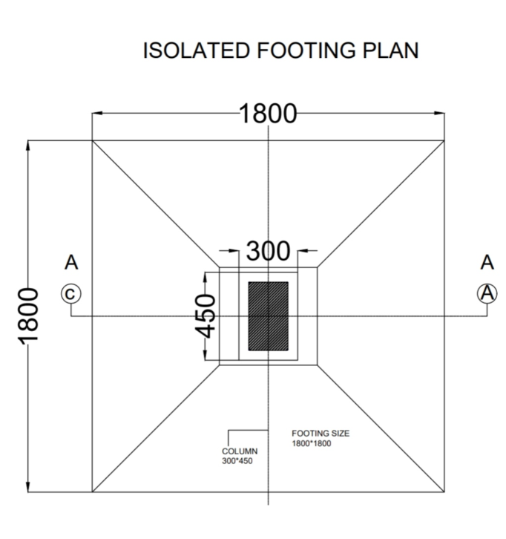

DRAWING – 2
Column and Footing Section (Section A–A)

Structural Details

Component | Dimension
Excavation Depth | 1500 mm
PCC Thickness | 100 mm
Footing Thickness | 400 mm
Pedestal Size | 1500 × 1000 mm
Column Size | 600 × 300 mm
Earth Cover | As per site

Reinforcement
- Bottom Bars: 12 mm Ø @ 150 mm c/c
- Top Bars: 12 mm Ø @ 200 mm c/c
- Column Main Bars: 8 Nos – 20 mm Ø
- Column Ties: 8 mm Ø @ 150 mm c/c

Section Includes
- Natural ground level
- Excavation
- PCC layer
- RCC footing
- Pedestal
- RCC column
- Reinforcement
- Dimensions
- Level markings

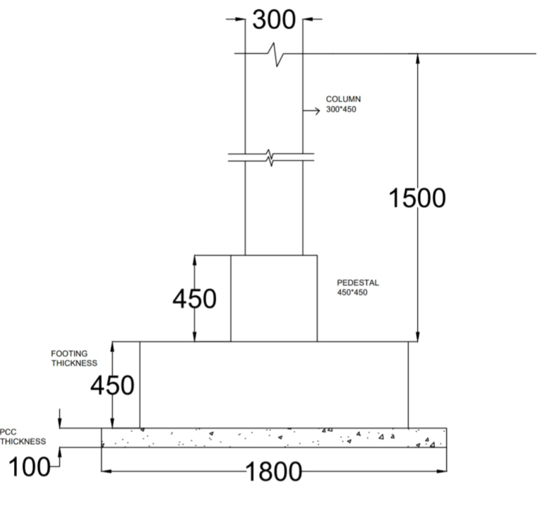

DRAWING – 3
Footing Bottom Reinforcement Plan and Bar Bending Schedule
The footing bottom reinforcement plan shows the mesh of main bars provided in both directions at the base of the footing. The bar bending schedule lists the mark, diameter, shape, number, and cutting length of every bar used in the footing and column.

Mark | Details
B1 – Bottom Bar | 12 mm Ø, straight, spaced @150 mm c/c both ways
C1 – Column Main Bar | 20 mm Ø, straight, 8 Nos
T1 – Tie Bar | 8 mm Ø, rectangular shape @150 mm c/c

DRAWING DETAILING WITH MEASUREMENTS

Column
- Size = 600 x 300 mm
- Height = 1500 mm

Footing
- Size = 3200 x 2200 mm
- Thickness = 400 mm

Pedestal
- Size = 1500 x1000 mm
- Height = 600 mm

PCC
- Thickness = 100 mm

Reinforcement
- Column Main Bars = 8 Nos – 20 mm Ø
- Column Ties = 8 mm Ø @ 150 mm c/c
- Footing Steel = 12 mm Ø @ 150 mm c/c

Concrete Cover
- Column = 40 mm
- Footing = 50 mm

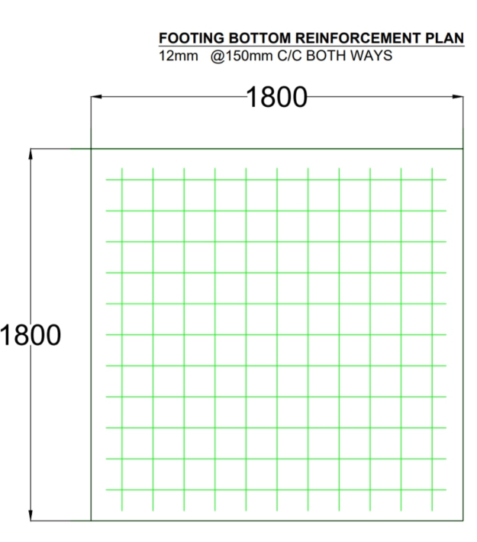

APPLICATIONS
- Residential Buildings
- Commercial Buildings
- Office Buildings
- Apartment Construction
- Industrial Structures
- Educational Buildings
- Structural Consultancy
- Foundation Design Documentation
- Construction Site Execution

ADVANTAGES
- Accurate structural detailing
- Easy drawing modifications
- Improved construction quality
- Faster drafting process
- Better communication between engineers and contractors
- Reduced drawing errors
- Compliance with IS standards
- Easy quantity estimation
- Professional documentation.

CONCLUSION

This project demonstrates the complete detailing of an isolated footing using AutoCAD, covering the footing plan, column and footing section, and bar bending schedule. Accurate reinforcement details, dimensions, and sectional views help ensure safe and economical foundation construction. AutoCAD enhances drafting quality, reduces errors, and improves productivity in structural engineering documentation.
An isolated footing is a simple and economical foundation used to support a single column. It transfers the load of the building safely to the soil. The size and depth of the footing depend on the column load and the soil bearing capacity. Proper reinforcement is provided to resist bending and shear forces. A well-designed isolated footing helps prevent excessive settlement and provides stability to the building. Therefore, proper design and construction of isolated footing are important for the safety and durability of a structure.



